 ***5/11/20***

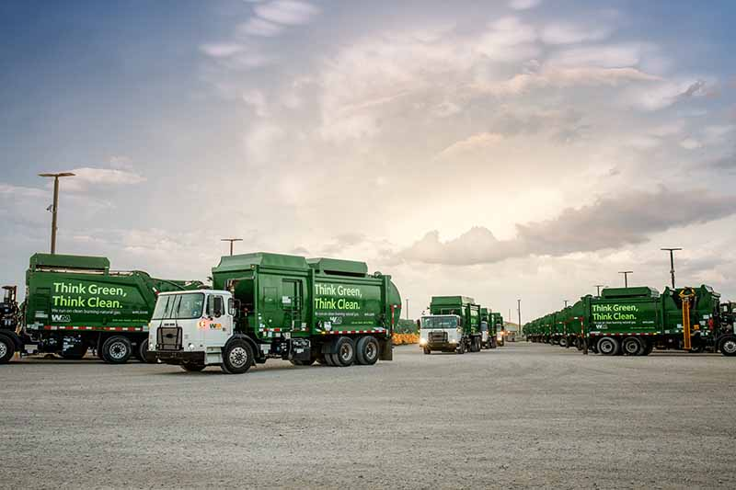

|  |  |  |  |  |  |
| --- | --- | --- | --- | --- | --- |
| |  |  |  |  |  | | --- | --- | --- | --- | --- | | |  |  |  |  | | --- | --- | --- | --- | | |  |  |  | | --- | --- | --- | | |  | | --- | | **Your Waste Management Service.** | | Dear Valued Customer,  Effective the week of May 11, we will resume the collection of bulky waste, such as furniture, carpet, mattresses, appliances. We ask residents with more than one, please schedule those additional items to be picked up over time. This is strictly to ensure our collection teams can complete all core services each week.  Thank you for being a Waste Management customer. We appreciate your patience during this time. If you have any questions, please contact us by chat at [www.wm.com](http://www.wm.com/); by email at [ilmovalcustomerexperience@wm.com](mailto:ilmovalcustomerexperience@wm.com); or by phone at (800) 964-8988.  For the most up-to-date service information, please visit [www.wm.com/alerts](http://www.wm.com/alerts). | | | | |